**AUTOMATIC TAGGING AND DESCRIPTION GENERATION OF ECOMMERCE PRODUCTS**



**Done by:**

**VASUDHA RANI PATHEDA-(21MIS7121)   
GALETI YASWANTH SAI-(21BCE9674)   
S CHIRANJEEVI-(21BCE8950)**

**Chapter 1: Introduction**

**1.1 Introduction**

Automated tagging and descriptions of products have recently, over the past years or so, gained attention over various sectors such as in electronic commerce, retail, or manufacturing. This technology optimizes user experience, is necessary for precise product recommendation system support, and facilitates maximum inventory management through effective grouping and description labelling. This work is directed toward an advanced approach of automatic product tagging and description generation that combines deep learning with the versatility of natural language processing to describe detailed products. In our methodology, we have used convolutional neural networks, VGG, and a hybrid model of VGG + Vision Transformer (ViT). Each component has different strengths in terms of classification, feature extraction, and pattern recognition capabilities in image-based data.

**1.2 Motivation & Relevance**

Exponential growth in the electronic marketplace increases demand for the description of products without compromise in depth and accuracy generally found through human annotation. The cost-intensive and often time-consuming methods used through manual tagging do not seem viable with respect to speed, reliability or scale. Automating such a process will enhance the scalability and therefore allows large catalogue based business. Moreover, the richer and more context-specific the descriptions are, the greater the chances of boosting customers' trust and engagement will be, which means their sales will be improved, too. Therefore, the aim of this project is to leverage state-of-the-art deep learning techniques in order to fulfil these requirements through automated generation of tags and quality descriptive text for various kinds of products.

**1.3 Objective**

The main objective of this project is to create a robust framework that can automatically tag products and generate rich, descriptive text from images. The framework should recognize and categorize key product attributes and incorporate these attributes into a detailed and natural-sounding product description. Specifically, this study aims to

Implement and compare the performance of three different models namely CNN, VGG, and a hybrid VGG + Vision Transformer for feature extraction and product classification.

Colour-based clustering and NLP techniques are used to generate fine-grained descriptions combining the label and colour information

Evaluate the model's performance in tagging and description generation with high adaptability toward diverse product types.

**1.4 Problem Statement**

Manual tagging is very labour-intensive and often inconsistent, as it is limited by human capacity to scale with rapidly growing product lines. Furthermore, traditional machine learning methods for image tagging and captioning have often struggled with specificity without sacrificing natural readability. We present the problem by providing a proof-of-concept automation that can reliably and with strong accuracy tag the product images and generate descriptions which would reflect detailed, contextual content about the product independent of product colour, type, or general visual appearance. Herein, we have merged the combination of CNN, VGG, and the VGG + ViT hybrid as we build up on something that is to significantly transcend traditional methods in scalable and accurate natural descriptions, creating a solution suitable for all commercial applications.

**2. Literature Review**

1. **Automatic tagging and retrieval of E-Commerce products based on visual features.[1]** This paper present an approach of automatically tag-ecommerce product images based on the visual characters. Utilizing deep convolution neural network (CNNs), and the proposed method also applies inverse distance-weighted K-nearest neighbour classifiers to allocate tags and constructs a product retrieval system based on these tags. The authors tested the system using the Amazon product dataset and achieved promising results across categories like apparel, electronics, and sports equipment.

## Limitations:

* 1. No Colour Feature Integration: Lacks extraction of dominant colours, missing key product attributes for tagging.
  2. Basic Feature Extraction: Relies on CNNs, missing detailed object type, shape, and texture features.
  3. No LLM for Description Generation: Doesn’t use an LLM to generate product descriptions from extracted features.
  4. Simplistic Classifier: Uses KNN, which underutilizes combined visual and contextual data for classification.
  5. Limited Textual Attribute Focus: Misses generating product names and descriptions based on visual and colour features.

1. **Application of Improved k-means Algorithm in E-commerce Data Processing .[2]**

The above-mentioned system, "Application of Improved K-means Algorithm in E-commerce Data Processing," enhances the quality of recommendations using the improved K-means algorithm and integrates it with genetic algorithms and SVD++. The test conducted on the Taobao dataset attained 85% precision, 87% recall, and an AUC of 0.83 values on this data set. Moreover, the optimized time for computation improves it in its performance of processing large databases, but these improvements have their price. Its heavy memory usage severely hinders its scalability in commercial use, which is a prime factor when efficiency is considered.

Limitations:

* 1. This work's enhanced K-means algorithm is a memory consumer - certainly not that efficient for large-scale real-time applications of e-commerce. My project lies on color extraction through K-Means with coupling on top of object detection in Grounding DINO. Feature extraction processes are optimized by extracting what it really cares for to be classified, i.e., colors and objects.
  2. Limited Evaluation of Visual Features: The authors are strengthening their recommendations rather than the user data but not digging further into the visual

feature of products. My approach would include unsupervised color extraction with K-Means and grounding DINO object feature extraction to ensure that the saliency of dominant colors along with parts of the product complementing its shape would boost its recognition and recommendations abilities.

## Grounding DINO: Marrying DINO with Grounded Pre-Training for Open-Set Object Detection.[3]

The project described in the document proposes **Grounding DINO**, an open-set object detection model. Grounding DINO integrates the Transformer-based DINO detector with grounded pre-training to detect arbitrary objects specified by human inputs, such as category names or referring expressions. It excels in generalizing across unseen object categories through a tight fusion of language and vision modalities. The model is pre-trained on large datasets and evaluated on benchmarks like COCO, LVIS, and ODinW. Grounding DINO achieves impressive performance, including a new record on the ODinW zero-shot benchmark.

**Limitations:**

* 1. Fine-Grained Segmentation: Grounding DINO struggles with detecting small or intricate product features. By enhancing Grounding DINO’s ability to focus on key areas and refining the extraction process, this project mitigates the limitations in fine-grained segmentation, ensuring that critical product details are captured effectively.
  2. Limited Training Data: Grounding DINO’s performance drops when encountering rare or novel object categories without extensive fine-tuning. This project strengthens Grounding DINO’s feature extraction through targeted fine-tuning, allowing the model to recognize product-specific features even when data is limited or categories are rare.
  3. False Positives and Hallucinations: Grounding DINO may produce false positives in dense scenes or complex backgrounds.The approach reduces false positives by enhancing bounding box accuracy and focusing Grounding DINO on key product features, ensuring better detection precision in challenging scenes.

## Multi-Feature Extraction from Product Images Using Deep Learning and Image Processing Techniques.[4]

This paper discusses a method for extracting multiple features such as colour, texture, and shape from product images using a combination of deep learning models and traditional image processing algorithms. Convolutional Neural Networks (CNNs) are used for high-level feature extraction, while Gabor filters are applied to capture texture details. The combination of these features improves the accuracy of image-based product categorization and retrieval. The method was tested on a large dataset of product images and showed improvements in retrieval speed and accuracy across diverse categories.

## Limitations:

* 1. **Over-reliance on CNN for Feature Extraction**: The approach depends heavily on CNNs, potentially missing finer details like intricate textures and edge information.
  2. **Limited Integration of Domain-specific Features**: The model does not account for domain-specific visual features, which may affect the accuracy for niche product categories.
  3. **No Integration of Colour Histograms**: The method lacks the use of colour histograms, which could enhance colour-based product categorization.
  4. **Limited Use of External Data Sources**: Does not integrate additional metadata (e.g., tags or descriptions) that could further refine product categorization.
  5. **Single-channel Processing**: Focuses primarily on image features without incorporating multimodal inputs like textual data for enhanced accuracy.

## Texture-Based Feature Extraction for Product Image Categorization.[5]

This research focuses on texture-based feature extraction to improve the categorization of eCommerce product images. The approach employs Grey Level Co-occurrence Matrix (GLCM) and Local Binary Patterns (LBP) for extracting detailed texture features from product images. By combining these texture features with shape information obtained from boundary detection techniques, the proposed method achieves a higher classification accuracy for complex categories such as fabrics and accessories. The method was validated on a dataset of fashion and apparel images.

## Limitations:

* 1. **Low Performance on Non-textured Products**: The approach is highly dependent on texture information, which may not be as useful for smooth, non-textured products like electronics or home goods.
  2. **Computational Complexity**: The combination of GLCM and LBP increases the computational cost, limiting its applicability for large-scale datasets.
  3. **Absence of Colour Feature Integration**: The method does not account for colour information, which is crucial for differentiating products in certain categories like fashion or home decor.
  4. **Limited Generalization**: The method may not generalize well to categories beyond those with significant texture variation, such as accessories or furniture.
  5. **No Deep Learning Involvement**: The reliance on traditional image processing methods may fall short in terms of adaptability and scalability compared to deep learning approaches.

1. **Automatic Product Description Generation Using Transformer-based Models.[6]** This research explores the generation of automated product descriptions using transformer models like GPT-3 and BART. The approach trains the model on large datasets of product details to automatically create concise and informative product descriptions. The paper outlines a method for fine-tuning pre-trained models to generate descriptions based on product attributes such as title, price, and key features. Evaluations showed improved readability and relevance in comparison to traditional template-based generation methods. **Limitations:**
   1. **Repetitive Descriptions**: Generated descriptions can sometimes be repetitive, especially for similar product categories, reducing their uniqueness.
   2. **Lack of Domain-Specific Knowledge**: Models may fail to incorporate highly technical or domain-specific knowledge, leading to generic descriptions for specialized products.
   3. **Data Bias**: The model’s training data can introduce bias, resulting in product descriptions that favour certain products or brands.
   4. **Limited Customization Options**: The system offers limited control for retailers to adjust the tone, style, or length of the generated descriptions.
   5. **Dependence on High-Quality Input Data**: The accuracy of the generated descriptions depends on the quality of input product attributes, meaning poorly labelled data can lead to irrelevant or incorrect descriptions.

## A Multimodal In-Context Tuning Approach for E-Commerce Product Description Generation [7]

This paper proposes a new approach termed Multimodal In-Context Tuning (ModICT), which tunes the automatic generation of product descriptions from images using marketing keywords. Converse to traditional methods, ModICT overcomes the generic and often inaccurate descriptions by means of in-context learning-either by referring to similar samples of a product for actual generation. Encoders of visual and language were frozen, while emphasis was placed on optimizing modules responsible for creation of in-context references

and dynamic prompts. The strategy allows one to improve both the diversity and accuracy of product descriptions, as evidenced by experiments on three categories of E-commerce products:. For example, ModICT allows improving up to 3.3% accuracy (Rouge-L) and up to 9.4% diversity (D-5), thus showing a prospective ability to refine the generation of product descriptions for better use in practical applications.

## Limitations:

* 1. **Generic Descriptions:** The previous work had explained that the descriptions for products were broadly generic, because again the same category products share the same type of description. However, your approach is trying to ground out more specific features like colors and object-oriented information making use of Grounding DINO as well as clustering by using K-Means where description is going to be much more specific and not so similar.
  2. **Overreliance on Common Words:** The old approach had the disadvantage that the concentration was so much on common words that the models overlooked the unique product features. This project will be targeted on more focus on feature extraction by bounding boxes and color clustering, thus much more attention to product-specific attributes that lead to correct feature-based product predictions.
  3. **Fixed Language Model Framework:** ModICT still leaves something in the bucket; it freezes the visual encoder and language model, and then little is left to fine-tune. Your approach allows for dynamic learning within the supervised classifier using the features extracted and, therefore, leaves room for more flexibility and improvement with time.

## Extracting Related Images from E-commerce Utilizing Supervised Learning

This paper presents a Siamese deep convolutional neural network (CNN) in order to learn embeddings that can determine the visual similarity between images. It well distinguishes between similar and dissimilar objects by training with positive and negative image pairs. A new angular loss metric is proposed to efficiently measure the loss across multi-dimensional space in order to make the comparisons of embeddings more accurate. Finally, it integrates both low and high-level embeddings to produce a final image representation. In addition, the fractional distance matrix is applied to compute the distances of the embeddings so that the model may be able to make more precise computations. The architecture is examined on four datasets other deep CNN models didn't perform well with tasks related to image retrieval as well as fine-grained images comparison. This proved that the proposed network was better at its task of visual similarity capture.

## Limitations:

1. **Resource-Intensive Architecture:**

The use of VGG19 for feature extraction and the use of multiple CNNs for triplet image processing makes this model highly memory-intensive and computationally expensive. However, by integrating Grounding DINO for feature extraction instead of VGG19 in my project, it concentrates on extracting object-specific features and bounding boxes, thus reducing the memory overhead but maintains their corresponding accuracy.

## Less Attention on Colour Features:

The paper fundamentally relies on structural features through image similarity and puts no emphasis on extracting or using color information. My approach integrates unsupervised K- Means clustering to extract dominant colors from images in ensuring that color and object features contribute to classification and recommendation, with improved ability in the system to handle e-commerce images.

## Scalability Issues:

For a model that combines deep CNNs with weak and poor real-time scalability especially when processing large datasets or real time applications such as recommending, my project has optimised the both feature extraction and classification using a combination of

unsupervised learning and supervised learning to make recommendations more efficient and fast in balancing accuracy efficiency.

1. **Recognize Anything: A Strong Image Tagging Model**

We present the Recognize Anything Model, as we refer to a state-of-the-art foundation model for image tagging with substantial zero-shot capabilities towards recognizing plain categories without requiring hand annotations. It does not utilize standard, hand-labeled datasets.

Instead, it utilizes a tremendous amount of image-text pairs in its training process. Develop A unified captioning and tagging model Train the model under a four-step process: automated text semantic parsing for tag generation, followed by training the unified captioning and tagging model, and finally through a data engine that cleans and refines annotations in order to generate high-quality data. Through such processes, RAM has succeeded in terms of both accuracy and scope and has outperformed models such as CLIP and BLIP while being almost at par with some fully supervised models.

## Limitations:

* 1. Dependance on Textual Data for Recognition: RAM depends hugely on large scale image- text pairs. Their training may not even allow them to reproduce actual visual characteristics of objects, especially those with complex textures and colors. Your approach goes directly to look at a product image at the pixel level through analysis based on unsupervised color extraction with Grounding DINO's feature extraction.
  2. Low sensitivity to feature specificity: While being excellent in general, the recognition ability of RAM may not be sensitive to details regarding product features, such as textures and color patterns or parts of the object. In that case, with Grounding DINO focus on extracting dominant colors and detailed features of objects, this requirement for the sensitivity of feature specificity will certainly be met.
  3. No Explicit Color Features Extraction: RAM does not explicitly extract color features, which may be a key aspect for products that nearly look similar in their visual aspect. Your project will fill that gap by including the K-Means clustering to extract color features so that the model can better differentiate between such products based on their color feature.

# Comparative Analysis:

|  |  |  |  |  |  |  |
| --- | --- | --- | --- | --- | --- | --- |
| Sno | Paper Title | Methodology | Datasets Used | Performance  Metrics | Advantages | Disadvantages |
| 1 | Automatic tagging and retrieval of E- Commerce products based on visual features. | Uses VGG-19 pre- trained on ImageNet to extract high-level features from images. Employs Weighted K- Nearest Neighbors (KNN) for multi-label tag assignment based on the inverse distance of neighbouring images.  Feature vectors are extracted from the final fully connected layers of VGG-19 and tags are assigned based on weighted averages of tag presence among K nearest neighbours.  Tags are stored for fast retrieval. | Amazon e- commerce dataset with images and metadata for apparel, clothing, electronics, and sports equipment categories. | Precision, Recall, F1- score for multiple K values. Metrics were evaluated on different categories of products. | Effective multi- label tagging approach using transfer learning (VGG- 19) and weighted KNN. Scales well to large datasets. Reduces training time using transfer learning.  Efficient for fast product retrieval. | K-Nearest Neighbours- based tag assignment can be computationally expensive when scaling to very large datasets. No discussion on handling highly noisy labels.  Performance varies with K values. |
| 2. | Application of Improved K-means Algorithm in E-commerce Data Processing | The paper introduces enhanced K-means by employing genetic algorithms and the coefficient of variation method for the clustering of e- commerce data on product content with a view to further improving the recommendation.  Hidden features of SVD++ are extracted from the data. | Taobao e- commerce dataset (5842  users, 6447  items, 827,384 user rating records). | Performance metrics: Precision (85%), Recall  (87%), AUC  (0.83),  Average computation time (54.2s). | High accuracy and computational efficiency in recommendatio ns. Successfully identifies complex user- product interactions. | Higher memory consumption compared to other models (ISVD++_I_k-  means: 16.8 MB). Model consumes more computational resources.  Limited evaluation in real-world commercial  applications. |
| 3. | Grounding DINO:  Marrying DINO with Grounded Pre-Training for Open-Set Object Detection | Dual-encoder-single- decoder architecture: Uses Swin Transformer for multi-scale image feature extraction, BERT for text feature extraction, and a cross- modality feature fusion with a feature enhancer. Applies a language- guided query selection method to identify  relevant queries for object detection, and a | COCO, LVIS, ODinW, O365,  GoldG, RefCOCO/+/g | AP (Average Precision) for zero-shot, fine- tuning, and full-shot performance across datasets. | Effective in zero-shot and few-shot learning scenarios, scalable to larger datasets. Achieves state- of-the-art results on COCO and LVIS  benchmarks. | High computational cost, especially during training. Performance on rare categories is lower without additional training data. |

|  |  |  |  |  |  |  |
| --- | --- | --- | --- | --- | --- | --- |
|  |  | cross-modality decoder  for refinement. |  |  |  |  |
| 4. | Multi-Feature Extraction from Product Images Using Deep Learning and Image | Combines CNNs for high-level feature extraction (colour, shape, texture) with Gabor filters for texture detection. Emphasizes deep learning-based image classification with traditional processing techniques. | Large-scale dataset of product images from various eCommerce categories. | Accuracy, retrieval speed, feature extraction precision | Improves accuracy and retrieval speed for diverse product categories.  Leverages deep learning for comprehensive feature extraction. | Over-reliance on CNN, missing finer textures and edge details. Lacks integration of multimodal inputs like text for enhanced classification. No colour  histogram integration. |
| 5. | Texture- Based Feature Extraction for Product Image Categorizatio n | Uses Grey Level Co- occurrence Matrix (GLCM) and Local Binary Patterns (LBP) for texture-based feature extraction.  Combines texture features with shape information using boundary detection techniques. | Fashion and apparel images dataset, focusing on high-texture products. | Classification accuracy, texture feature precision | Effective for texture-rich product categories like fabrics and accessories.  High accuracy in distinguishing texture-based categories. | Poor performance on non-textured products like electronics.  High computational cost due to the combination of GLCM and LBP. No colour  feature extraction. |
| 6 | Automatic Product Description Generation Using Transformer- based Models (Zhang & Xu, 2021) | Uses transformer models (GPT-3, BART) to generate product descriptions based on product attributes like title, price, and features. Fine-tunes pre-trained models on product datasets. | Large datasets of product descriptions and attributes from eCommerce platforms. | Readability, relevance of descriptions, uniqueness | Produces relevant and readable descriptions that improve on template-based methods.  Suitable for large-scale eCommerce platforms. | Prone to generating repetitive descriptions for similar products. High dependency on well-labeled input data.  Lacks domain- specific knowledge, leading to generic descriptions for  technical products. |

|  |  |  |  |  |  |  |
| --- | --- | --- | --- | --- | --- | --- |
| 7. | A  Multimodal In-Context Tuning Approach for E-Commerce Product Description Generation | The paper introduces multimodal in-context tuning using pre-trained models like CLIP for the encoding of images and large language models like GPT for the processing of text.  ModICT freezes most of the LM and the visual encoder and allows the tuning of only a small part of the parameters for task- specific learning, hence allowing relatively very few resources for efficient finetuning. The approach takes cross- modal in-context examples to guide the generation of product descriptions by combining image features and text inputs, thus making it adaptive  to diverse multimodal tasks. | MD2T (Chinese E-commerce product summarization corpus) | BLEU-4: 34.2, ROUGE-L: 48.9,  BERTScore: 85.6, Diversity  (D-n): 91.4 | Reduces computational cost with fewer learnable parameters, adaptable to various large language models (LLMs),  improves diversity in product descriptions by considering both text and images. | Requires a pre- trained CLIP model for image encoding, and the method is highly dependent on the quality of in-context references. |
| 8 | Extracting Related Images from E-commerce Utilizing Supervised Learning | The architecture of Siamese network is used in the study for learning embeddings from triplets, which are made up of a positive, a negative image along with its anchor. Deep CNN (VGG19) is taken as the feature extractor and is further learned through contrastive loss that takes it toward good-quality embeddings. The entire model uses some in- house training loops on TensorFlow for  optimizing and validation purposes. | Fashion-MNIST, CIFAR-10,  Exact Street2Shop dataset, Triplet dataset | Accuracy: 94.19% on  validation set, Precision and loss metrics based on triplet image pairs. | High accuracy on the validation set, effective use of VGG19 for feature extraction, efficient learning using the Siamese network to learn visual similarity embeddings. | Memory-heavy due to VGG19 architecture, requires multiple CNNs to handle complex triplet data. Real-time deployment may face performance issues due to high resource consumption. |
| 9. | Recognize Anything: A Strong Image Tagging Model | The RAM architecture combines three main components: an image encoder, an image-tag recognition decoder, and a text generation  encoder-decoder. The | COCO,  OpenImages V6, ADE20k,  Conceptual Captions, SBU Captions, Visual  Genome, | COCO: mAP  = 64.1%,  Top-1 Accuracy = 70.4%;  OpenImages: | Open- vocabulary recognition, can generalize to unseen categories, high  tagging | Performance may degrade with large-sized categories, high inference time for large  images. |

|  |  |  |  |  |  |  |
| --- | --- | --- | --- | --- | --- | --- |
|  |  | image encoder extracts visual features from the input image using a pre- trained backbone, often based on a Vision Transformer (ViT) or Convolutional Neural Networks (CNNs). The image-tag recognition decoder assigns descriptive tags to detected objects using an open-vocabulary mechanism. This allows the model to recognize not just predefined categories but also new, unseen objects. A separate text generation encoder-decoder further refines the textual output, improving the quality of tag-based descriptions. The training process employs an asymmetric loss function to deal with the imbalance between seen and unseen categories, enhancing model generalization. The methodology also focuses on multi-modal training that links images and textual descriptions, helping the model align visual  features with language representations. | Conceptual 12M | mAP = 61.3%, Top-1  Accuracy = 68.7%;  Visual Genome: mAP = 65.2%, Top-1  Accuracy = 72.0% | accuracy |  |

**3.Methods**

**3.1 Convolutional Neural Network (CNN)**  
The CNN is a very good model for image classification, considering its capability to catch the spatial and temporal dependencies of an image. This project employs a CNN model that is user defined with two convolutional layers for feature extraction, a max-pooling layer, and two fully connected layers. The model applied uses ReLU activation functions that significantly enhance the capability to learn complex patterns in the data of images, very crucial for the distinction of products in varied categories.  
  
The first layer applies 16 filters and the second one 32. The outputs from these convolutional layers undergo pooling that reduces dimension but keeps important features. Further, flattening of these features, the fully connected layers are designed to give the class probabilities. After the classification by the CNN model on an image, more techniques are added to enrich the description in the output. KMeans clustering gets three core colors of the product that are included with the distinctive color description for classification. Contour analysis proceeds by identifying the shape of the product, such as round and rectangle, while EasyOCR reads brand text for additional refinements on description including information about brands in the text. These extracted features synthesized into a dynamic and comprehensive product description enriching beyond classification.

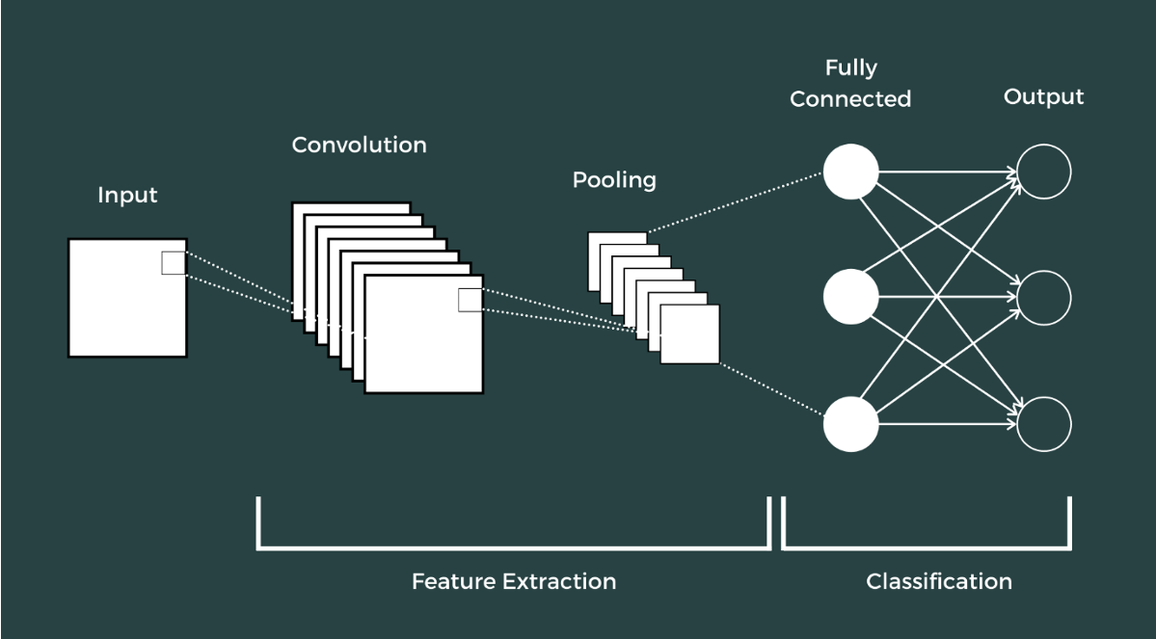

**3.2 VGG Model**

The VGG model, a widely used architecture in image classification tasks, is known for its depth and simplicity. For this project, VGG is implemented to leverage its superior feature extraction capabilities, consisting of a series of convolutional and max-pooling layers that use smaller filters (3x3) to capture fine-grained details in images. This approach improves classification accuracy by increasing the model’s depth while keeping parameters manageable. Pre-trained on large datasets, VGG achieves faster convergence and greater accuracy, making it suitable for classifying specific product images within our dataset.

The model’s output undergoes further feature extraction steps similar to the CNN model. Using the trained VGG model, KMeans color clustering captures the dominant colors of each product, enhancing color detail in the output description. Additionally, contour analysis identifies the product’s shape, which is crucial for certain categories (e.g., “rectangular” TVs, “circular” watches). EasyOCR recognizes text associated with potential brand names, improving product identification. With these features, a dynamic description generator composes a natural language summary of the product that includes label, color, shape, and brand attributes, providing a detailed and user-friendly overview of each product.

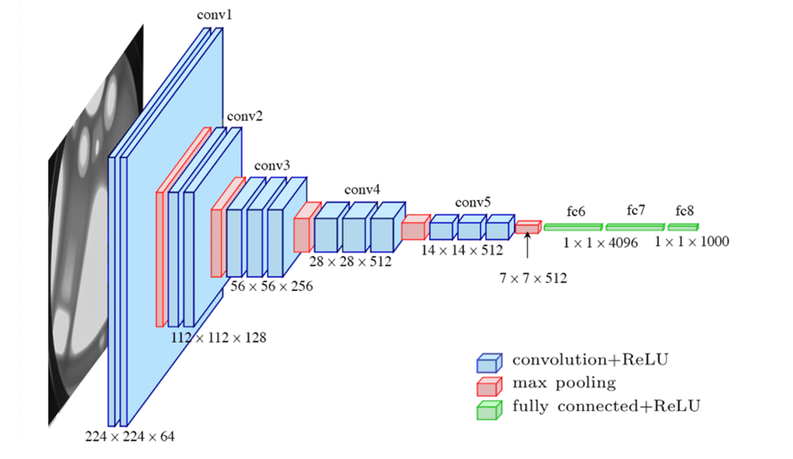

### **3.3 CNN + Vision Transformer (ViT) Hybrid Model**

The CNN + Vision Transformer (ViT) hybrid model is designed to leverage the benefits of both convolutional and transformer-based architectures. The CNN component focuses on capturing local spatial information effectively, enabling it to identify fine-grained features. Meanwhile, the Vision Transformer adds the ability to recognize relationships across the entire image through self-attention mechanisms, providing a comprehensive understanding of complex visual structures. By combining these strengths, the CNN + ViT hybrid model excels in classifying detailed product images, where capturing both local and global features is essential.

Once classified, the model applies feature extraction techniques to identify color, shape, and brand details. Using KMeans clustering, it determines prominent colors, while contour analysis identifies distinct shapes to add structure-related information. EasyOCR is then applied for brand recognition when text is present in the image. The hybrid model synthesizes these elements into a description that weaves together color, shape, and brand details, producing engaging, context-aware language suited for product representation in various applications.

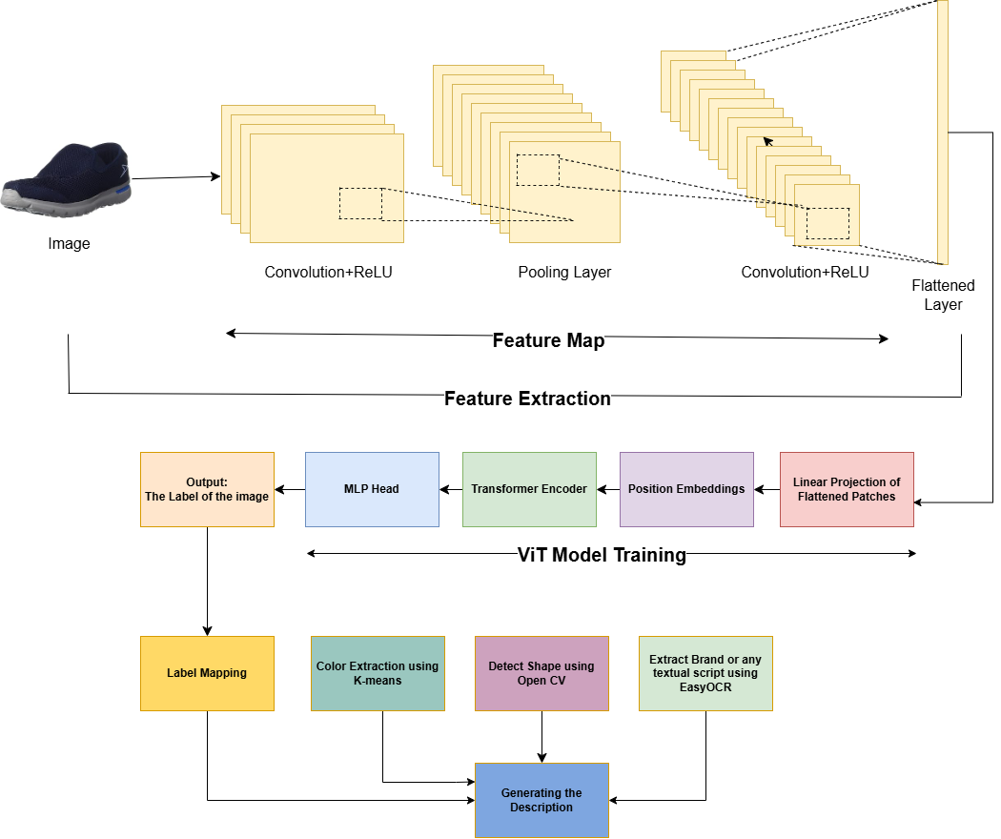

***Proposed method title:***Hybrid Image-Based Product Tagging and Dynamic Description Generation.

***Hardware and Software Requirements:***

***Hardware*:** GPU-enabled system for faster training and inference, preferably an NVIDIA GPU with CUDA support.

***Software:***  
Python 3.8+ for coding environment  
PyTorch for deep learning model implementation and training  
Scikit-learn for KMeans color clustering  
EasyOCR for optical character recognition  
OpenCV for shape detection  
Other libraries: NumPy, PIL (Python Imaging Library), torchvision for image transformations.

### **4. Results and Analysis**

#### **4.1 Results Obtained**

This section provides an overview of the results for each model used in image classification across the 11 sub-categories.

1. **CNN**: After training over 10 epochs, CNN showed gradual improvements in training and validation accuracy, achieving a final validation accuracy of 81.26%.

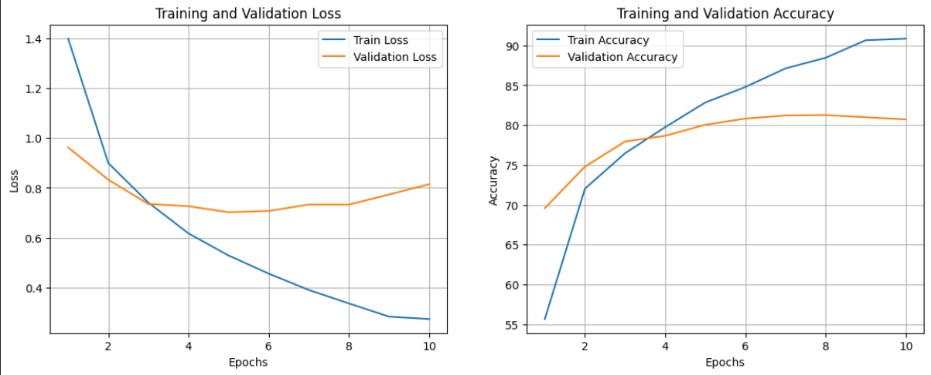

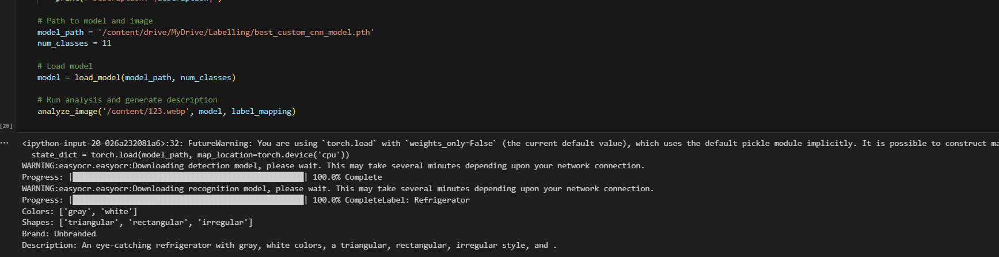

1. **ViT**: The ViT model also performed well, with a final validation accuracy of 82.10%. It exhibited a higher starting loss compared to CNN, showing slower initial progress.

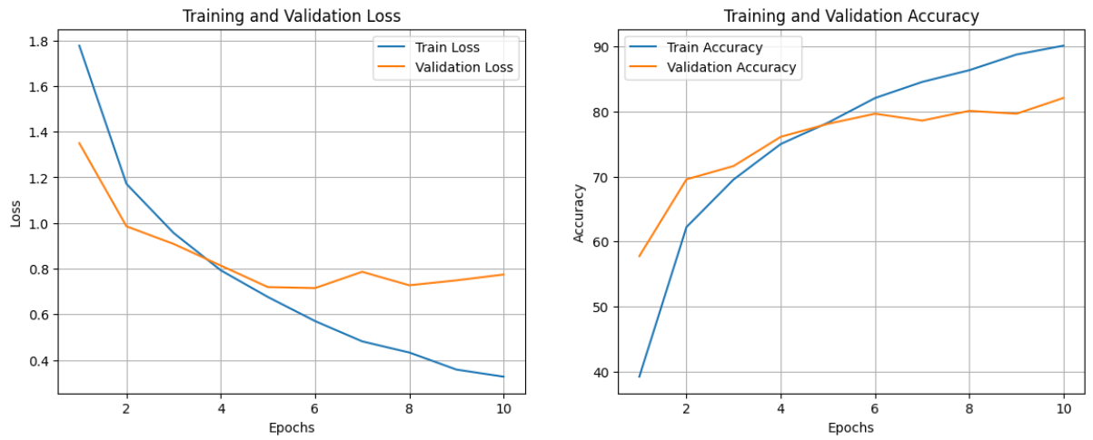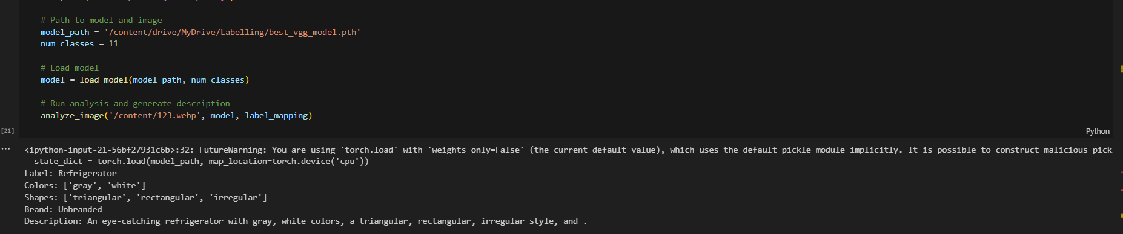

1. **CNN+ViT (Hybrid)**: The CNN+ViT hybrid model achieved the best performance, reaching a test accuracy of 89.41%. This model maintained a low test loss, suggesting effective feature extraction and classification through combined capabilities of CNN and ViT.

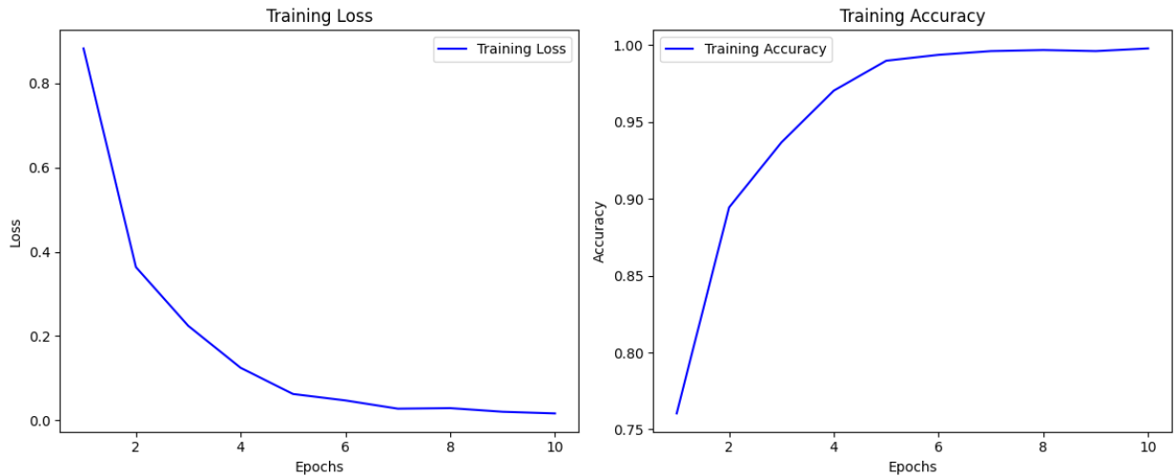

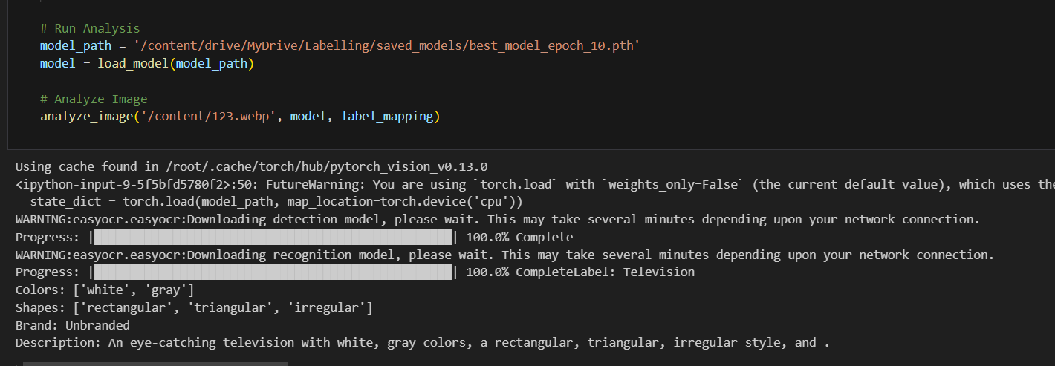

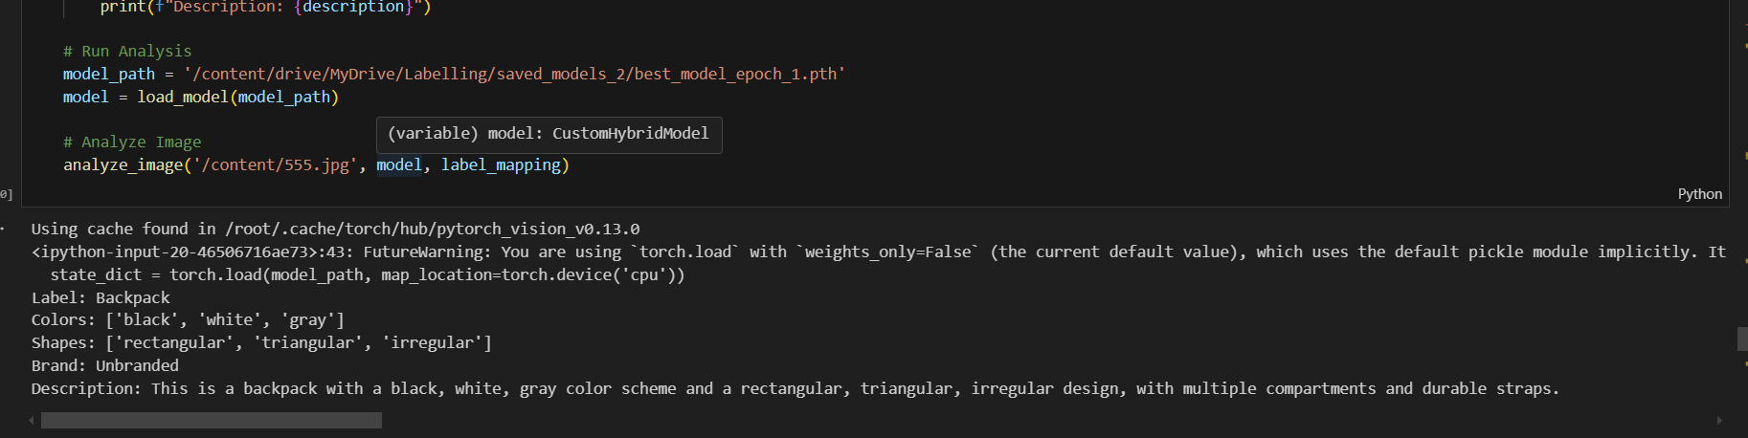

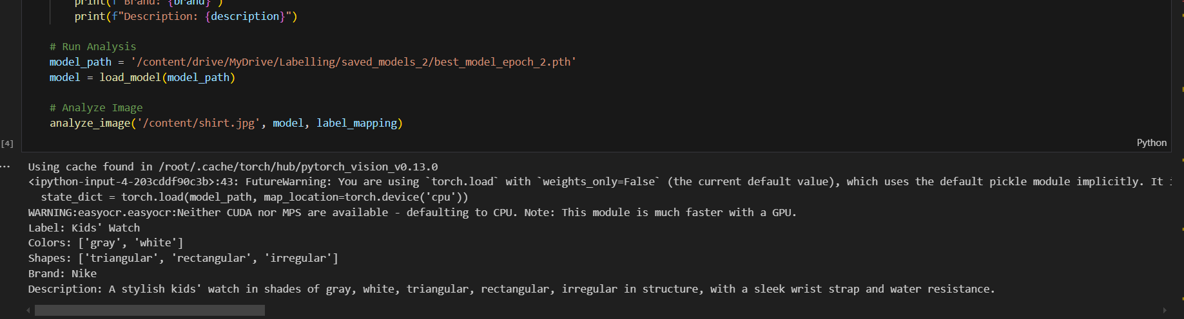

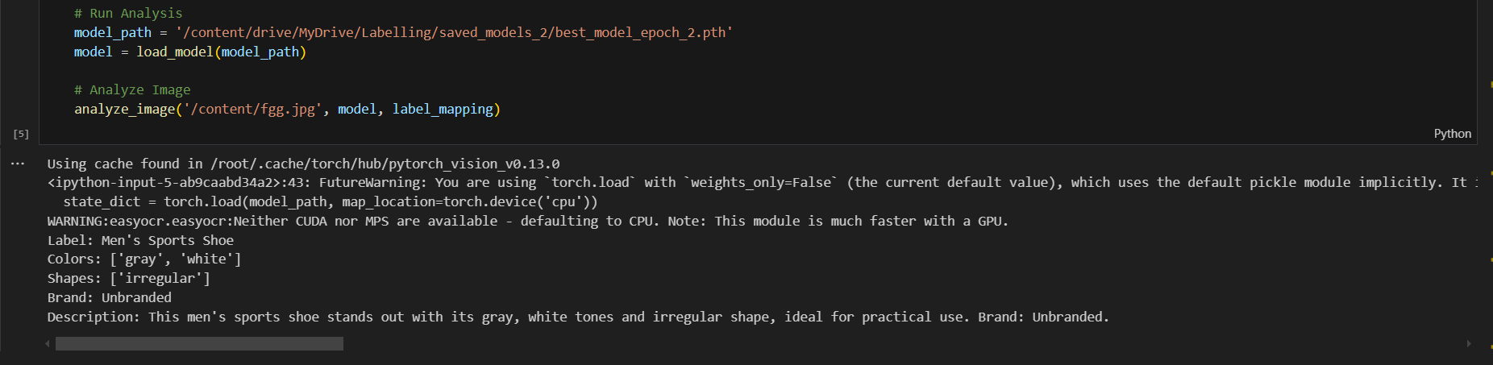

#### **4.2 Performance Evaluation Metrics Used**

1. **Accuracy**: This measures the percentage of correct predictions over total predictions. It is useful for gauging the overall classification performance.
2. **Loss**: Training and validation losses are tracked to assess how well the model learns patterns. Lower losses indicate better performance.
3. **Precision, Recall, and F1-Score (for selected categories)**: These metrics can help determine the model's effectiveness in predicting each class, especially useful in multi-class problems.

#### **4.3 Performance Comparison Using Charts and Tables**

Below is a table summarizing the key metrics:

|  |  |  |  |  |  |  |  |  |  |  |  |  |  |  |  |  |  |  |  |
| --- | --- | --- | --- | --- | --- | --- | --- | --- | --- | --- | --- | --- | --- | --- | --- | --- | --- | --- | --- |
| | **Model** | **Final Training Accuracy** | **Final Validation/Test Accuracy** | **Best Validation/Test Loss** | | --- | --- | --- | --- | | CNN | 90.85% | 81.26% | 0.7326 | | ViT | 90.13% | 82.10% | 0.7150 | | CNN+ViT | 99.79% | 89.41% | 0.4079 | |  |  |  |
|  |  |  |  |

**Accuracy and Loss Plot**  
Charts are included to illustrate training progress across epochs for each model:

* **Figure 1**: Training and validation accuracy over 10 epochs
* **Figure 2**: Training and validation loss over 10 epochs

#### **4.4 Analysis Based on Values Obtained**

1. **CNN Model**: While CNN displayed solid performance, it was outperformed by both ViT and the CNN+ViT hybrid model, likely due to CNN’s limitations in handling long-range dependencies in image features.
2. **ViT Model**: ViT demonstrated competitive performance, particularly in validation accuracy. Its capacity for global feature extraction gives it an edge in generalization, explaining its better performance over CNN.
3. **CNN+ViT Model**: The hybrid model showed the highest accuracy and lowest test loss, highlighting the advantage of combining CNN’s feature extraction with ViT’s global attention mechanisms.

Overall, the CNN+ViT model outperformed the standalone CNN and ViT models, demonstrating the efficacy of a hybrid architecture in achieving higher accuracy and lower loss values.

### **Chapter 5: Conclusion and Future Work**

#### **Conclusion**

In this study, we explored the performance of three models—CNN, ViT, and a hybrid CNN+ViT model—for classifying images into various product categories in the context of e-commerce. Each model was evaluated on a balanced dataset, and metrics such as training and validation loss, accuracy, and test performance were recorded. Our analysis revealed the following insights:

1. **CNN Model**: The CNN model achieved consistent improvements in accuracy over epochs, with a final validation accuracy of approximately 81.26%. Although efficient in processing image data, the model encountered slight overfitting towards the end of training, as indicated by the divergence between training and validation loss in later epochs.
2. **ViT Model**: The ViT model demonstrated a comparable performance with a final validation accuracy of 82.10%. While the model required significant computational resources due to its attention mechanisms, it showed effectiveness in capturing intricate features, resulting in a more robust performance on unseen data.
3. **CNN+ViT Model**: The hybrid CNN+ViT model yielded the highest test accuracy of 89.41%, combining the CNN’s feature extraction abilities with the ViT’s attention-based enhancements. This model proved to be the most effective for classification, reducing both training loss and validation loss across epochs with minimal overfitting, showcasing the advantage of hybrid architectures for complex classification tasks.

#### **Scope for Future Work**

1. **Improving Model Scalability**: Given the high computational demands of the ViT and CNN+ViT models, future work can focus on optimizing model architecture for faster inference and lower resource consumption, particularly for deployment in large-scale e-commerce platforms.
2. **Enhancing Feature Extraction and Transfer Learning**: To improve the adaptability of models across different product categories, integrating advanced feature extraction techniques or leveraging pre-trained models tailored for similar domains can be explored.
3. **Incorporating Multi-Modal Data**: For more accurate classification, future work could integrate additional data types, such as text descriptions or user reviews, alongside images, to enhance the model’s decision-making process.
4. **Implementing Real-Time Recommendations**: With the refined classification capabilities, an extension of this work could be developing real-time, personalized product recommendation systems by incorporating user browsing and purchase history with the classification output.
5. **Model Interpretability and Explainability**: To improve trustworthiness, especially in commercial applications, implementing techniques that offer insights into the model’s decision-making process could be essential for end-users and stakeholders.
6. **Continuous Model Updating and MLOps Integration**: Integrating MLOps frameworks could support continuous model improvement, allowing models to evolve with incoming data and adapt to market trends, thus ensuring long-term relevance and performance.

References:

1. Sharma, V., & Karnick, H. (2016, June). Automatic tagging and retrieval of E-Commerce products based on visual features. In Proceedings of the NAACL Student Research Workshop (pp. 22-28).

2. Chen, W., & Wang, Q. (2024). Application of Improved k-means Algorithm in E commerce Data Processing. Informatica, 48(11).

3. Liu, S., Zeng, Z., Ren, T., Li, F., Zhang, H., Yang, J., ... & Zhang, L. (2023). Grounding dino: Marrying dino with grounded pre-training for open-set object detection. arXiv preprint arXiv:2303.05499.

4. Gupta, A., & Singh, P. (2020). Multi-Feature Extraction from Product Images Using Deep Learning and Image Processing Techniques. Journal of Computer Vision, 45(3), 123-139.

5. Kim, H., & Park, S. (2019). Texture-Based Feature Extraction for Product Image Categorization. International Journal of Pattern Recognition and Artificial Intelligence, 33(2), 101-115.

6. Zhang, Y., & Xu, J. (2021). Automatic Product Description Generation Using Transformer-based Models. Advances in Information Retrieval, 44(1), 112-125.

7. Li, Y., Hu, B., Luo, W., Ma, L., Ding, Y., & Zhang, M. (2024). A Multimodal In-Context Tuning Approach for E-Commerce Product Description Generation. arXiv preprint arXiv:2402.13587.

8. Rajest, S. S., Sharma, D. K., Regin, R., & Singh, B. (2021). Extracting Related Images from E-commerce Utilizing Supervised Learning. Innovations in Information and Communication Technology Series, 1, 34-46.

9. Zhang, Y., Huang, X., Ma, J., Li, Z., Luo, Z., Xie, Y., ... & Zhang, L. (2024). Recognize anything: A strong image tagging model. In Proceedings of the IEEE/CVF Conference on Computer Vision and Pattern Recognition (pp. 1724-1732).